Ade Muhamad Ramdani  Software Engineer & IoT Systems Specialist  Rust · Embedded Systems · Full-Stack · AI/ML · DevOps | auricvex@gmail.com  +62 851-5622-0832  Kuningan, Jawa Barat, Indonesia  linkedin.com/in/auricvex  github.com/auricvex | 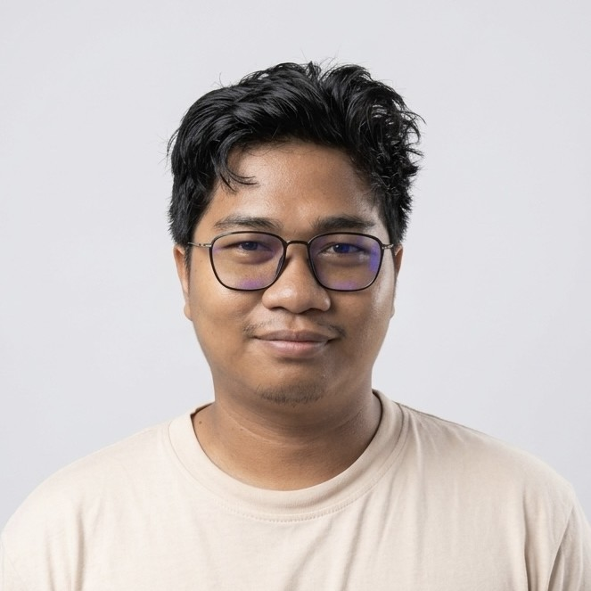

PROFESSIONAL SUMMARY / Ringkasan Profesional

Versatile software engineer with 6 years of experience spanning embedded systems, IoT firmware, full-stack development, AI/ML engineering, and infrastructure management. Core expertise in Rust for systems and IoT programming, with proven ability to architect and deliver end-to-end solutions — from low-level device firmware on ARM SBCs to production-grade backends and machine learning pipelines. Most recently served as CTO at PT. Sans Athan Group (until April 2026), leading Smart City product development across IoT, AI/ML, and backend domains. Currently available and actively seeking new opportunities.

Insinyur perangkat lunak serbaguna dengan 6 tahun pengalaman di bidang sistem tertanam, firmware IoT, pengembangan full-stack, AI/ML, dan manajemen infrastruktur. Keahlian utama di Rust untuk pemrograman sistem dan IoT, dengan kemampuan merancang solusi end-to-end dari firmware perangkat keras hingga backend produksi dan pipeline machine learning. Terakhir menjabat sebagai CTO di PT. Sans Athan Group (hingga April 2026). Saat ini tersedia dan aktif mencari peluang baru.

WORK EXPERIENCE / Pengalaman Kerja

Chief Technology Officer (CTO)  PT. Sans Athan Group | Jan 2025 – Apr 2026  Nganjuk, Indonesia

- Led full technical ownership of MyRTS (Smart City audio streaming platform) and Viswork (AI-powered vehicle & pedestrian monitoring system), overseeing architecture, development, and deployment.
- Built and maintained the Viswork backend in Rust — handling real-time data ingestion from CCTV networks, ML inference pipelines, and REST/WebSocket APIs for city-wide traffic monitoring dashboards.
- Designed and trained object detection & counting models using PyTorch for research/prototyping, then ported production-ready models to Burn (Rust ML framework) for optimal performance and deployment.
- Managed cloud infrastructure and on-premise servers: provisioning, CI/CD pipelines, Docker containerization, database administration (PostgreSQL, MongoDB), and monitoring/observability with OpenTelemetry.
- Functioned as sole engineer across backend, AI/ML, DevOps, and IoT domains — collaborating with a team of UI/UX designers, data annotators, and frontend developers.
- Memimpin pengembangan teknis penuh untuk MyRTS dan Viswork — merancang arsitektur, membangun backend, melatih model AI, dan mengelola seluruh infrastruktur server perusahaan.

Rust Software Engineer  PT. Sans Athan Group | Sep 2024 – Dec 2024  Nganjuk, Indonesia

- Architected and built the MyRTS backend from scratch in Rust — a Smart City audio broadcasting system enabling scheduled and live audio streaming to IoT devices deployed in remote city locations.
- Implemented real-time audio streaming using WebRTC protocol with secure, low-latency communication between the management server and field-deployed IoT endpoints.
- Developed embedded firmware for Raspberry Pi, OrangePi, and Radxa SBC devices — enabling encrypted two-way communication with the central MyRTS server over public networks.
- Integrated PostgreSQL for scheduling, device registry, and audit logging; designed robust API contracts for the frontend and mobile applications.
- Membangun backend MyRTS dengan Rust dan WebRTC serta firmware IoT untuk perangkat Raspberry Pi, OrangePi, dan Radxa sebagai bagian dari ekosistem Smart City PT. Sans Athan Group.

Independent Software Developer  Freelance / Self-employed | 2020 – 2024  Remote, Indonesia

- Delivered full-stack web and mobile applications for clients across DeFi, e-government, and enterprise sectors over 4+ years as an independent developer.
- Built DeFi platforms and Web3 integrations, including smart contract interfaces and transaction management dashboards.
- Developed government information systems and public service portals under client confidentiality agreements.
- Maintained end-to-end responsibility: requirement gathering, system design, development, deployment, and post-launch maintenance.
- Mengerjakan proyek DeFi, web, dan sistem pemerintahan secara mandiri selama 4 tahun, dengan tanggung jawab penuh dari desain hingga deployment.

OPEN SOURCE PROJECTS / Proyek Open Source

otel-rs
Modern, composable OpenTelemetry observability helpers for Rust — simplifying distributed tracing and metrics instrumentation in Rust services.
dotling
Dotfiles management tool — streamlining system configuration portability and reproducible development environment setup.
flakeenv (VS Code Extension)
VS Code extension that automatically loads environment variables from flake.nix (nix develop) and .envrc (direnv) into the workspace — bridging the gap between Nix dev shells and editor tooling.

TECHNICAL SKILLS / Keahlian Teknis

Languages / Bahasa Pemrograman: Rust, Go, TypeScript/JavaScript (Node.js), Python, Dart
Frontend: SvelteKit, React (basic), Flutter (mobile), Tauri (desktop apps)
Backend & APIs: Axum, Actix-web, Express.js, WebRTC, REST, WebSocket
AI / ML: PyTorch (research & training), Burn (Rust ML framework), Computer Vision, Object Detection & Counting
IoT & Embedded: Raspberry Pi, OrangePi, Radxa SBC, ARM firmware, Embedded Rust, UART/I2C/SPI protocols
Databases: PostgreSQL, MongoDB
DevOps & Infrastructure: Docker, Nix/NixOS, Linux server administration, CI/CD, OpenTelemetry, Prometheus
Tools & Environment: Git, VS Code, Neovim, direnv, Nix Flakes

CERTIFICATIONS / Sertifikasi

Scientific Computing with Python — freeCodeCamp
View credential →

EDUCATION / Pendidikan

SMP (Sekolah Menengah Pertama) — Junior High School, Indonesia
Predominantly self-taught engineer — 6 years of hands-on professional experience across systems programming, AI/ML, IoT, and full-stack development.

LANGUAGES / Bahasa

Bahasa Indonesia: Native / Ibu
English: Professional working proficiency (reading, writing, technical communication)

